Petrache Stefania-Larisa

Java Spring Project

# **Project theme:** Library management

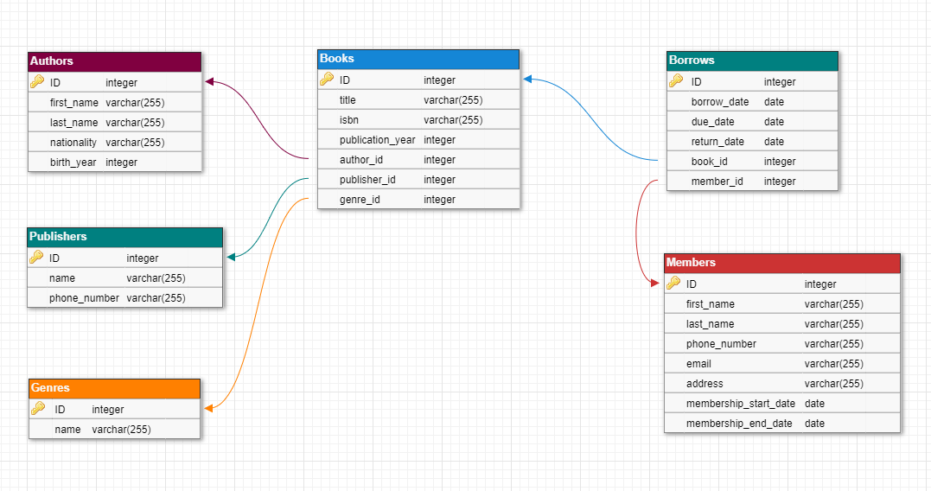 The application should display informations about library’s books, library’s members, book’s authors and publishers, as well as the borrow record. For this project, I have defined the following database:

The database has **6 entities**: Books, Authors, Publishers, Genres, Members and an additional entity named Borrows which keeps track of the borrowing record.

In the database, we have **4 relations**. There are 3 relations of type 1-M between Books – Authors, Books – Publishers and Books – Genres. There is also a 4th relation of type M-M between Books – Members, which is modeled through an additional entity named Borrows. The last entity Borrows will have informations about members and the books they borrowed, the date when a member borrowed a book (borrow_date), the date when the member has to return the book (due_date) and the date when the book was returned (return_date).